3. Data Flow and System Behavior
Data Flow & System Behavior

This design document explains how security events move from organizational sources into the SIEM, become actionable alerts, and are recorded as cases or approved response actions.

Table of Contents
- 1. Purpose, Scope, and Assumptions
- 2. Data-Flow Glossary and Canonical Data Model
- 3. Data-Flow Diagrams (DFDs): Context and Level 1
- 4. Sequence Diagram: From Event Ingestion to Alert Triage
- 5. Activity Diagram: SOC Analyst Workflow
- 6. State Diagram: Alert Lifecycle
- 7. Class Diagram: Entities and Relationships
- 8. System Behavior, Exceptions, and Security Controls
- 9. Validation Scenarios and Acceptance Criteria
- 10. Design Summary and Glossary

1. Purpose, Scope, and Assumptions
This section describes the proposed SIEM’s operational behavior: security events are collected, validated, normalized, evaluated against detection rules, enriched with asset and threat-intelligence context, then presented to an analyst for a documented decision. The goal is to make each event traceable from source through closure while preserving evidence and audit records.

1.1 System Boundaries
- In scope: log sources, the collection/broker layer, parsing and normalization, the event store, correlation engine, context enrichment, alerts and cases, analyst interface, and SOAR/ticketing connectors when enabled.
- Operating principle: An alert alone must not trigger a high-impact action on an asset or account. Such actions require a clear approval policy and a record of who performed the action and its result.

1.2 Design Assumptions
Area | Assumption | Design impact
Platform | Splunk, Elastic, or Wazuh in the lab; the design is vendor-neutral. | Replace search and normalization interfaces with features of the selected product.
Environment | A medium-sized, multi-system organization: endpoints, network, identity, cloud, and applications. | Each source has a source ID, event timestamp, and ingestion timestamp.
Time | Use UTC where possible and retain the original time zone. | Supports event ordering and helps detect clock drift.
Response | The analyst sets the verdict and escalation; SOAR is optional. | No automatic isolation or blocking without a policy and approval.
Data | Events may contain personal or sensitive data. | Apply role-based access, data minimization, and defined retention.

2. Data-Flow Glossary and Canonical Data Model
To reduce differences between products, each record is converted into a canonical event (Normalized Event). The system retains a secure reference to the raw payload for verification and does not replace original evidence with an analysis result.
Logical field | Meaning / example | Validation notes
event.id | Unique ID assigned to the normalized event | Keep it stable during reprocessing where possible to prevent duplicates.
event.time | Time the activity occurred | Retain the source time zone; do not replace it with ingestion time.
event.ingested | Time the event entered the platform | Used to measure delay and detect late-arriving events.
event.dataset / source | Source type and dataset | Examples: endpoint.auth, firewall.traffic.
event.category / action | Event category and action | Example: authentication / logon.
event.outcome | Result of the operation | success / failure / unknown; document any mapping.
user.id / user.name | Account ID and display name | A stable ID is better than a name alone; normalize the domain.
source.ip / destination.ip | Source and destination IP addresses | Validate the format and distinguish internal from external addresses.
host.id / host.name | Device ID and hostname | Link to a trusted asset ID; retain aliases where needed.
process.name / process.id | Process name and ID | Available only for some sources; do not assume it exists in every event.
rule.id / rule.version | Detection rule and version | Copy the evaluated version to the alert for later review.
event.original_ref | Reference to the raw payload | Apply separate permissions and retention.

2.1 Example of a Normalized Event
This example is illustrative. Actual field names may vary by product. Do not store credentials or secrets in an event.
{
"event": {"id": "evt-7f21", "time": "2026-10-24T17:12:04Z",
"ingested": "2026-10-24T17:12:07Z", "category": "authentication",
"action": "logon", "outcome": "failure",
"dataset": "identity.auth"},
"user": {"id": "u-1042", "name": "analyst.test"},
"source": {"ip": "203.0.113.25"},
"host": {"id": "idp-01", "name": "idp.example.local"},
"event.original_ref": "archive://2026/10/24/evt-7f21"
}

3. Data-Flow Diagrams (DFDs)
The diagrams show system boundaries, external entities, processes, and data stores. Arrows represent defined data flows, not simply network connections. The design keeps raw data, normalized data, detection rules, and case records separate.

3.1 Context-Level DFD
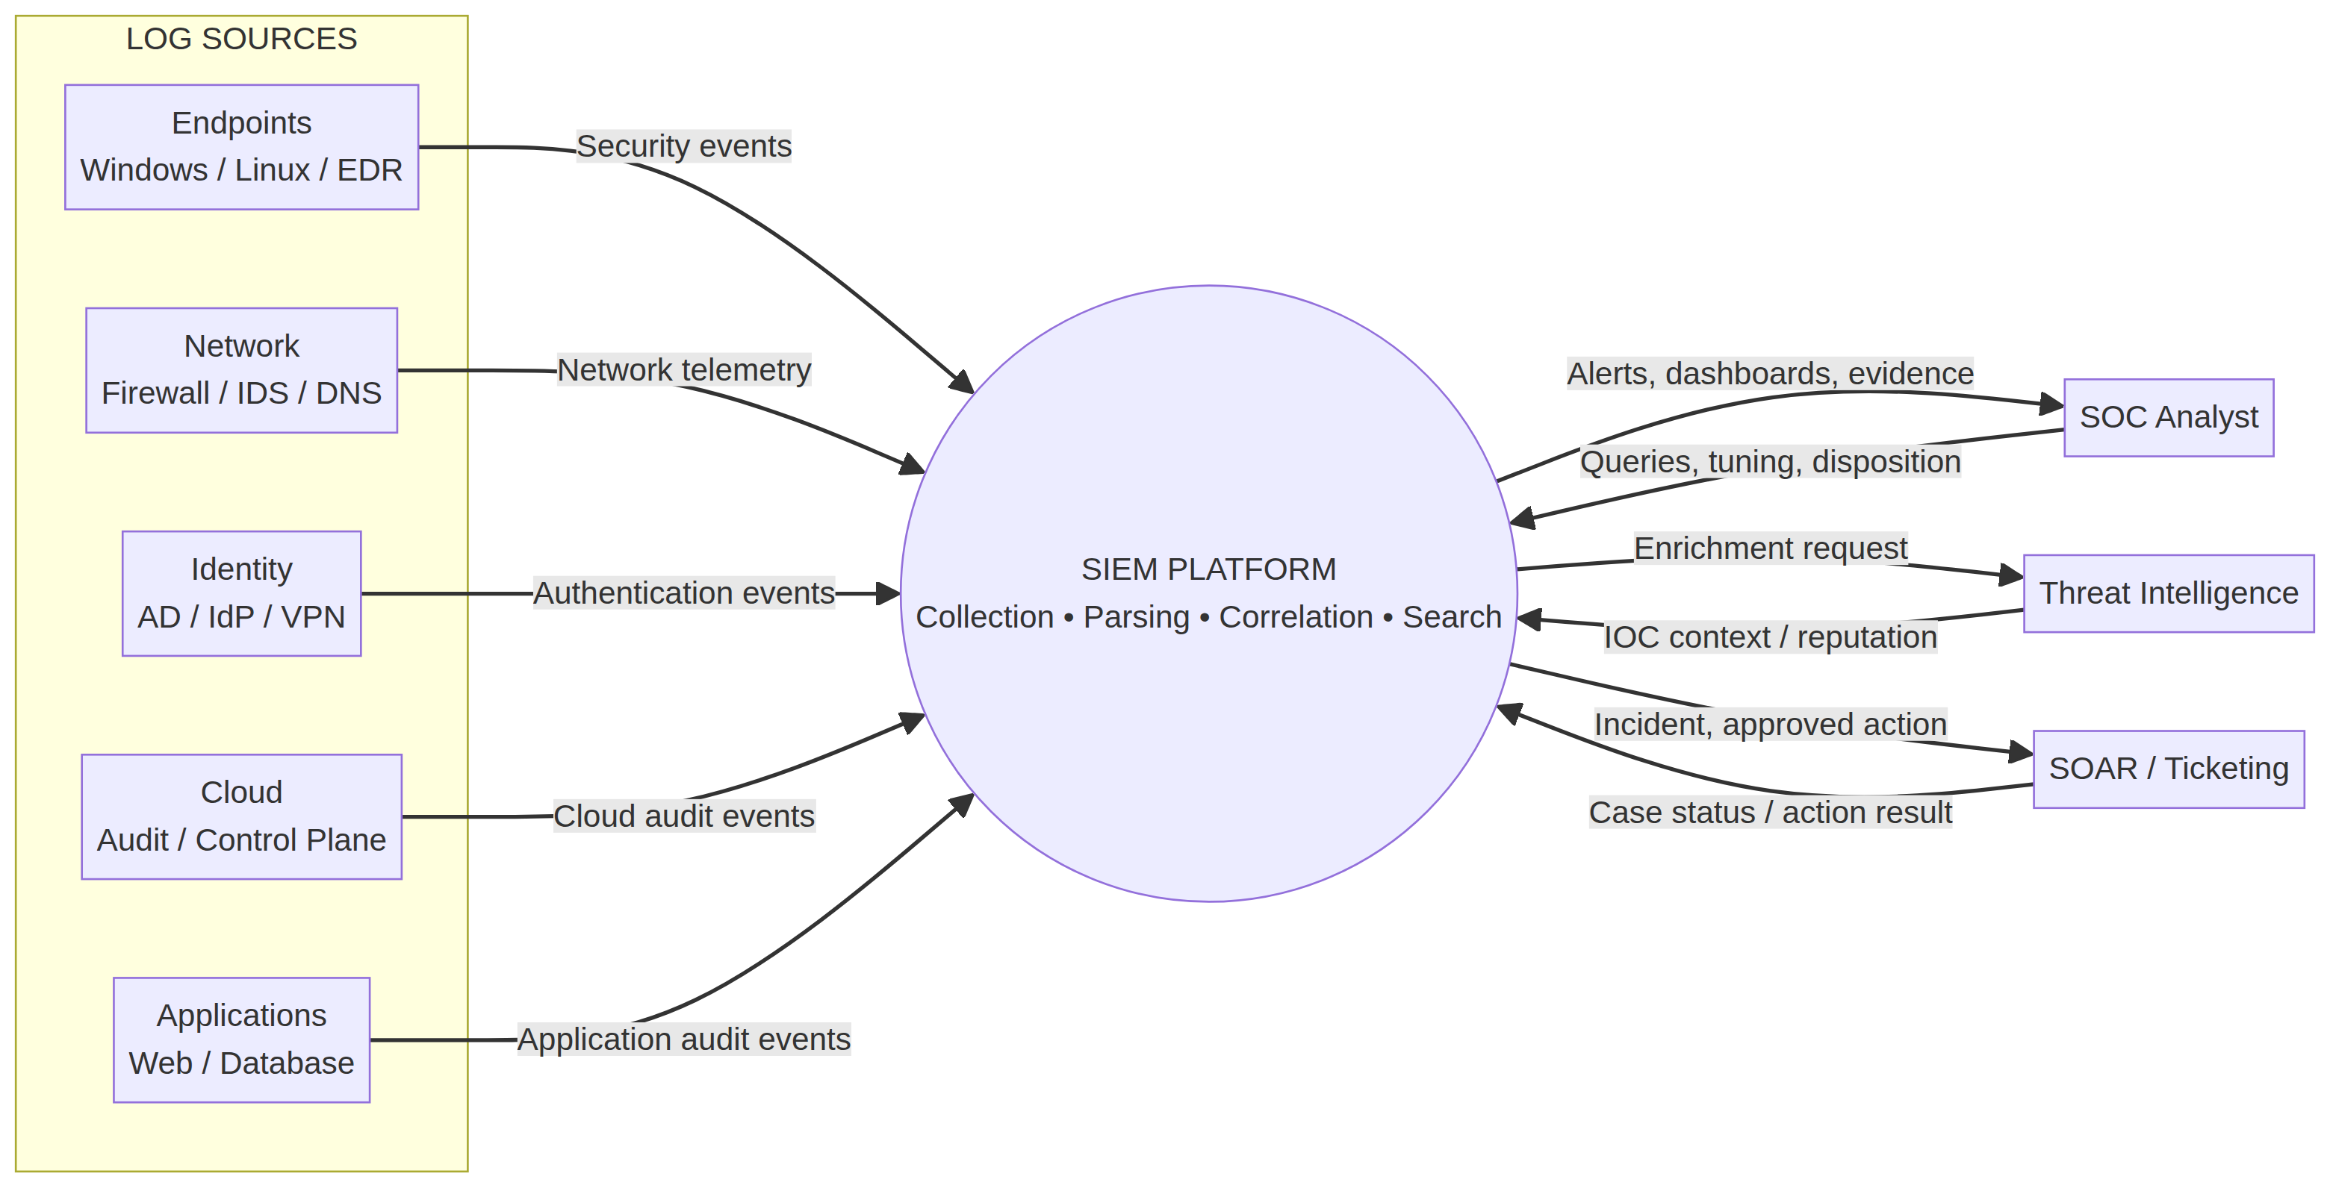
Figure 1. Context diagram: event sources, the SIEM platform, SOC analyst, threat intelligence, and response connector.
The platform handles five source groups: endpoints, network, identity, cloud, and applications. It receives events and produces alerts, dashboards, and investigation evidence for the analyst. The threat-intelligence source provides indicator reputation and context. SOAR or the ticketing system receives cases or approved action requests and returns execution results. The arrows do not mean that every integration is enabled in the lab.

3.2 Level-1 DFD
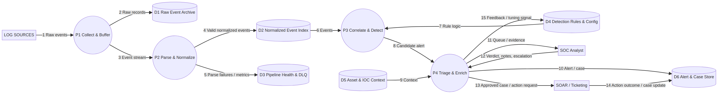
Figure 2. Processes and data stores from ingestion through case documentation.
ID | Responsibility | Main input / output
P1 — Collect and Buffer | Validate the envelope, add ingest_id, absorb bursts, and retry. | Raw record to archive; event stream forwarded.
P2 — Parse and Normalize | Extract fields, map to the canonical schema, validate, and deduplicate. | Valid event to the index, or rejected event to the DLQ.
P3 — Correlate and Detect | Evaluate threshold, sequence, and behavioral rules against events. | Alert with rule_id/version and supporting evidence.
P4 — Triage and Enrich | Enrich account, asset, and indicator context; present alerts; save analyst decisions. | Documented case, escalation, or action request; tuning feedback.
D1–D6 — Data Stores | Separate raw logs, indexed events, health data, configuration, context, and cases. | Retention, permissions, and audit controls depend on data type.

3.3 Core Data-Flow Rules
- Keep event time, ingestion time, log source, and processing-path ID. A timestamp alone is not enough to reconstruct the sequence.
- Quarantine parsing errors with their cause and parser version. Do not drop them silently or treat them as valid behavior.
- The collection layer should support back-pressure and bounded retries. Use an idempotency key to prevent duplicates and monitor queue size.
- Each alert must record its rule and version, supporting events, enrichment context and source, and the person who changed its status or severity.

4. Sequence Diagram: From Event to Triage Decision
The sequence diagram shows interactions among the source, collector, normalizer, detection engine, enrichment services, analyst, and case store. It includes two key alternatives: successful vs. failed parsing, and a detection match vs. no match.
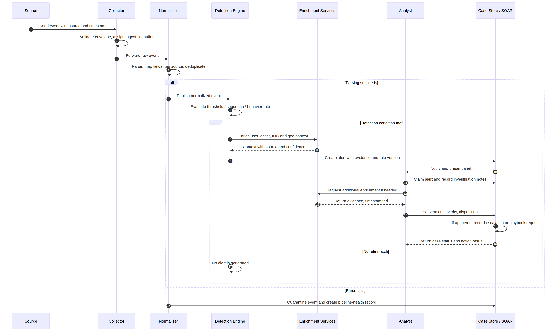
Figure 3. Sequence for processing a security event and triaging an alert, including alternate parsing and detection paths.

4.1 Interaction Steps
Step | Interaction | Result / quality control
1 | The source sends a record with its source ID and event time. | Reject an invalid envelope and count the rejection reason.
2 | The collector validates the record, adds ingest_id, and buffers it. | Retries do not create duplicate records.
3 | The normalizer extracts fields and applies a schema version. | Keep the raw reference and record the parser/schema version.
4 | The detection engine evaluates the rule. | No match: the event remains searchable and no alert is created.
5 | A match triggers enrichment and alert creation. | Record the source, confidence, and timestamp for each enrichment item.
6 | The analyst receives the alert and records evidence and a verdict. | Record who changed the status and when.
7 | If allowed, escalation calls the case or SOAR connector. | Return the action result and audit reference to the case.

5. Activity Diagram: Analyst Workflow
The activity diagram turns daily work into clear decision points. The analyst checks alert quality, links it to an existing case if it is a duplicate, and enriches it with identity, asset, and threat-intelligence context. The alert is closed only after the basis for the decision is recorded.
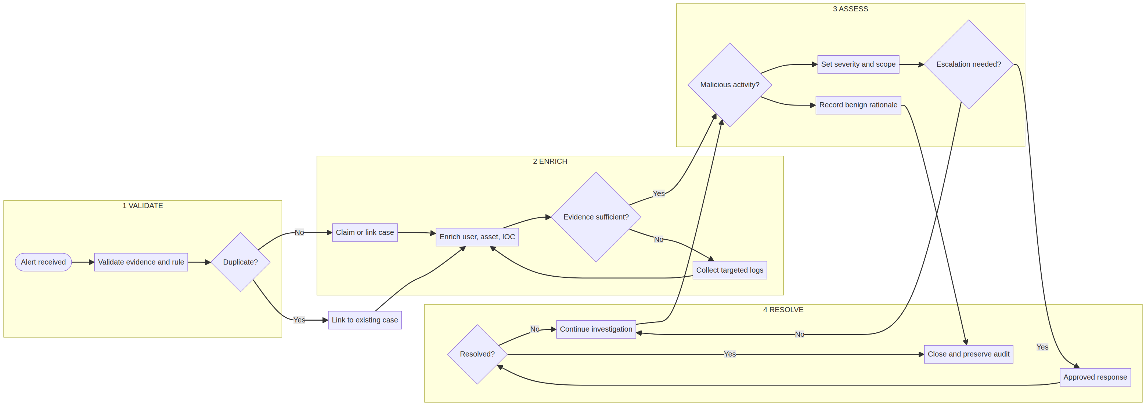
Figure 4. Alert-triage workflow from receipt through closure or escalation.

5.1 Required Analyst Outputs
- Classification: confirmed true positive, suspicious and requiring follow-up, or benign/false positive, with an evidence-based reason.
- Scope: related accounts, assets, IP addresses, events, and the time period reviewed.
- Action: monitor, collect more evidence, escalate, or request approved containment; record the owner and approver.
- Closure: a clear summary, evidence list, detection rule and version, and closure time.

6. State Diagram: Alert Lifecycle
The state diagram defines allowed states and transitions to prevent premature closure or undocumented status changes. Pending means waiting for evidence or an owner; it does not mean the alert is resolved. Reopen a closed alert if new evidence contradicts the closure or expands the scope.
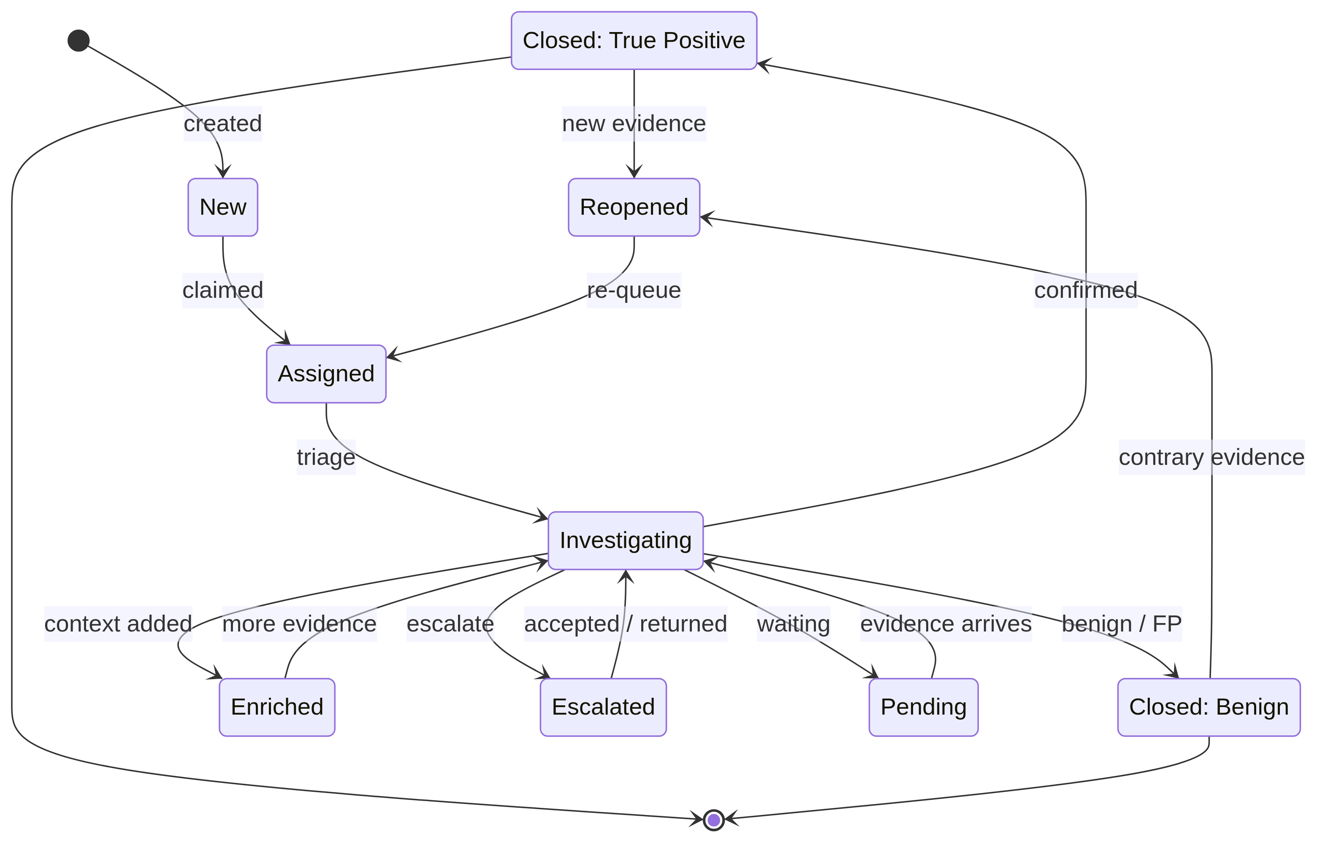
Figure 5. Alert lifecycle: assignment, investigation, escalation, closure, and reopening.
Status | Meaning | Expected transitions / constraint
New | Created by the detection engine; not yet assigned. | Moves to Assigned when claimed by an analyst or work queue.
Assigned | An investigation owner is known. | Moves to Investigating when triage starts.
Investigating | Evidence collection and assessment are in progress. | May move to Enriched, Escalated, Pending, or a closed state.
Enriched | Context has been added with its source. | Return to investigation when more evidence is needed.
Escalated | Referred to a higher-level team or owner. | Return to investigation when accepted or returned with a note.
Pending | Waiting for information or an owner. | Must not close automatically; return to investigation when evidence arrives.
Closed - True Positive | Malicious activity confirmed and handled or handed off to the relevant team. | Reopen if new evidence appears; document the decision.
Closed - Benign | Benign activity or a false positive, with a clear reason. | Reopen if new evidence contradicts the decision.

6.1 State Invariants
- For each transition, record the previous and next states, actor_id, timestamp, comment or reason, and evidence reference when relevant.
- Closing an alert requires a verdict, disposition, and reason. Alerts and their transition history must not be deleted.
- Enriched is not a verdict of malicious activity. Enrichment provides context and does not replace evidence assessment.

7. Class Diagram
The diagram shows the system’s logical entities and relationships. It is a conceptual model, not a final database or API design. An alert links to the rule that generated it. One or more alerts may be grouped into a case. Evidence links to events, assets, and threat indicators.
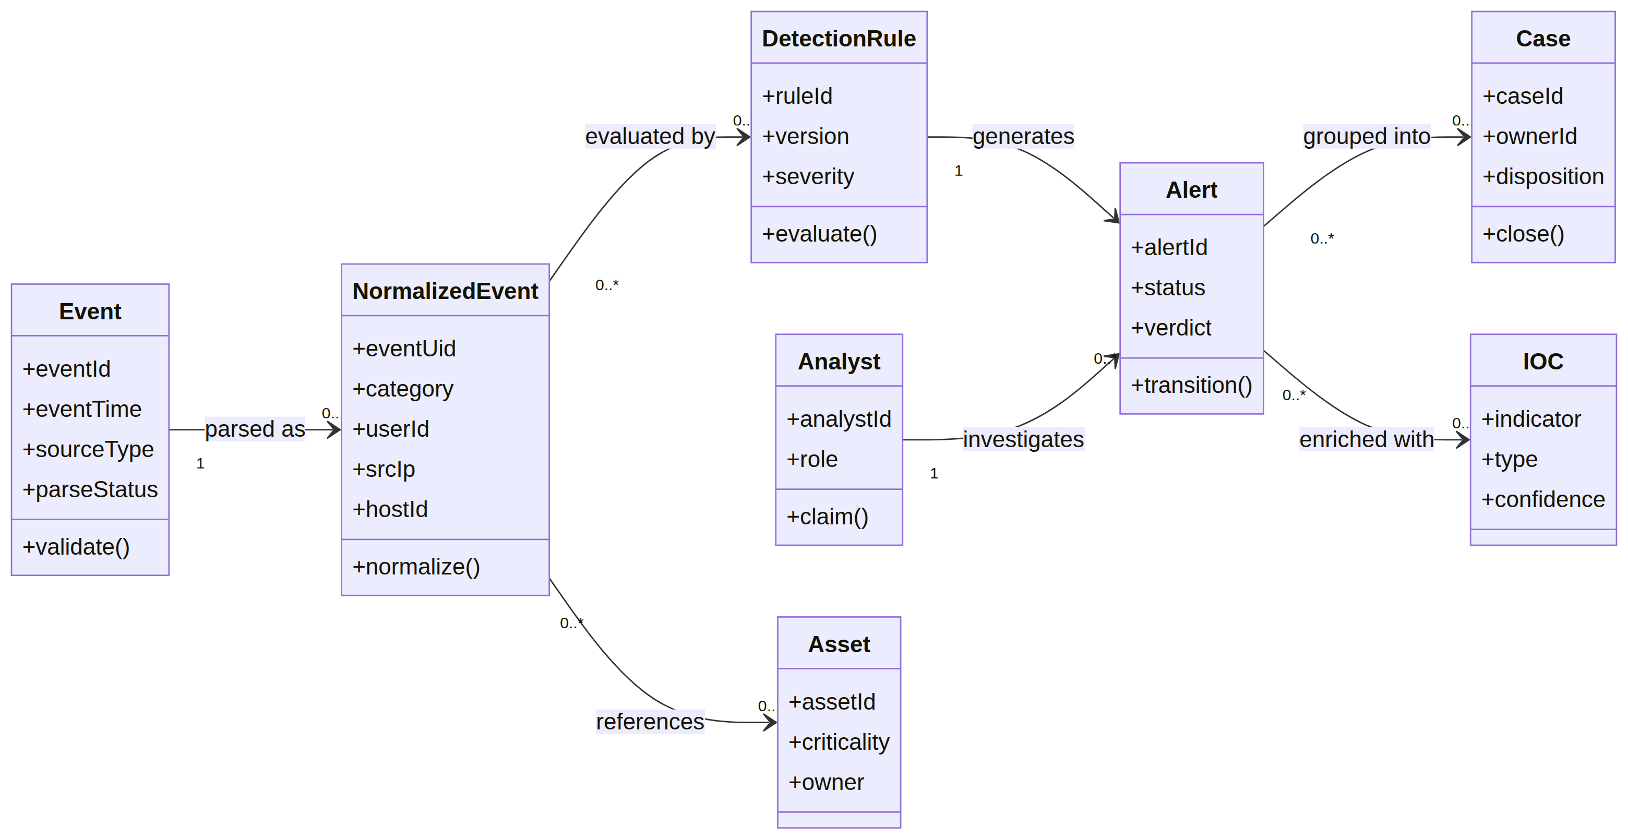
Figure 6. Class model: Event, Normalized Event, Detection Rule, Alert, Case, Analyst, Asset, and IOC.
Class | Main responsibility / data | Consistency controls
Event | Raw payload or reference, event and ingestion times, source, and parse status. | Do not change the original; record the parser version.
NormalizedEvent | Queryable normalized fields linked to the raw event. | Record the schema/version; do not invent optional fields.
DetectionRule | Rule ID, name, version, logic, severity, and enabled state. | Store the evaluated version in the alert.
Alert | Detection result, status, severity, verdict, and evidence. | Unique ID; controlled and audited state transitions.
Case | Investigation record that may contain alerts, evidence, and an owner. | Avoid unnecessary duplicate cases and keep links clear.
Analyst | Analyst identity, role, claim actions, and documentation. | Apply least-privilege access.
Asset | Asset, owner, criticality, and network zone. | Record the inventory source and last update time.
IOC | Indicator, type, source, confidence, and expiration time. | Check confidence and expiry to avoid stale enrichment.

8. System Behavior, Exceptions, and Security Controls

8.1 Exception Handling and Recovery
Condition | Expected behavior | Operational signal
Log source stops reporting | Do not assume there is no threat. Track the last event time and alert on a source gap. | source_last_seen; ingestion gap.
Enrichment service is unavailable | Create the alert without an unlimited wait, mark enrichment_status=degraded, and retry. | Enrichment delay / failure rate.
Late event or clock drift | Keep event time, ingestion time, and estimated drift; do not rewrite the raw event order. | event_lag and clock_skew.
Event cannot be parsed | Quarantine it in the DLQ with reason, source, and parser version; allow repair and replay. | Parser-error count and DLQ age.
Duplicate record | Merge or mark as duplicate using a stable key and defined time window. | duplicate_count; do not delete source evidence.
High load / full queue | Apply back-pressure, scale capacity, or alert an operator; never drop data silently. | queue depth and oldest message age.
SOAR error | Keep the case and show the action as failed or pending; never record assumed success. | action status and correlation ID.

8.2 Data Privacy and Security
- Encrypt data in transit and at rest where supported by the lab. Use separate key management and permissions where available.
- Use role-based access control. Analysts should access only the data needed for an investigation; rule management and retention settings should be limited to authorized roles.
- Minimize data collection. Do not collect content that is not needed for detection or store secrets or plain-text passwords. Mask sensitive fields in views and reports.
- Set separate retention policies for raw logs, indexed events, alerts, and case attachments. Document deletion, archiving, and legal-hold requirements.
- Protect audit logs from tampering where the environment allows. Record searches, exports, and sensitive actions.
- Treat log content as untrusted input. Do not execute text or commands found in a log or allow them to change analyst or automation instructions.

8.3 Data-Flow Health Metrics
Metric | Suggested definition | Why it matters
Ingestion latency | event.ingested minus event.time, adjusted for clock drift. | Detect transport delay or source-clock problems.
Source coverage | Active expected sources divided by all expected sources. | Detect gaps in visibility.
Parse success rate | Events parsed successfully divided by events received. | Measure connector and schema quality.
Queue backlog | Queue depth and age of the oldest unprocessed event. | Predict loss or processing delay.
Enrichment failure rate | Eligible alerts that could not be enriched divided by all eligible alerts. | Show context limits in analyst decisions.

9. Validation Scenarios and Acceptance Criteria
Run these scenarios in a safe lab using test logs or sanitized data. The goal is to validate data flow and system behavior, not to perform harmful activity on a production network.
ID | Scenario | Expected result / acceptance evidence
DF-01 | Valid event from an identity source | Indexed with event/ingestion times, source, user fields, and correct outcome.
DF-02 | Unexpected event format | Quarantined in the DLQ with parser version and reviewable reason; not silently dropped.
DF-03 | Same event sent again | Does not create unnecessary duplicate alerts; the replay remains auditable.
DF-04 | Source temporarily stops | Source gap / last-seen time is visible; missing events are not shown as proof of safety.
DF-05 | Event matches a test rule | Alert includes rule_id/version, evidence, timestamps, and asset/user when available.
DF-06 | Event does not match a rule | No alert is created; the event remains searchable within access permissions.
DF-07 | IOC service is unavailable | Alert is created with degraded enrichment; investigation can continue manually.
DF-08 | Alert moves to Pending and returns | Transition history, owner/reason, and reopening time are recorded.
DF-09 | Alert closed as false positive | A reason and disposition are required and appear in the audit trail.
DF-10 | SOAR request fails | Failure/pending result is shown; the action is not recorded as successful.

9.1 Document and Design Acceptance Criteria
- Every major source has a path to the collection layer, and each output to the analyst or response system is defined.
- The context and Level-1 DFDs distinguish external entities, processes, data stores, and data flows.
- The sequence diagram covers success, failure, and no detection match.
- The activity diagram includes evidence-based decisions and paths for escalation and closure.
- The state diagram prevents unjustified closure and shows how an alert can be reopened.
- The class diagram shows the event, rule, alert, case, analyst, and context concepts.
- Failure, privacy, audit, duplicate, and late-event handling are defined.

10. Design Summary and Glossary
The design follows a clear path: reliable collection → traceable normalization → reproducible detection → enrichment with known sources → documented human decision → audited case or action. Separating raw events, normalized events, alerts, and cases makes investigations repeatable and helps measure log-source quality.
Term | Meaning | Term | Meaning
DFD | Diagram showing processes, data stores, and data flows. | Normalized Event | Event mapped to a canonical schema.
DLQ | Quarantine for events that could not be parsed. | IOC | Indicator of compromise, such as an IP, domain, or file hash.
SOAR | Coordination and automation of security response. | Idempotency | Preventing duplicate effects when a record is resent.
False Positive | Benign alert; tune the rule.

